 |  |  | DC RESISTIVE LOAD BANK 440V/20A
We have attained a matchless position in the market as a Leading Manufacturer and Supplier of Load Banks.
These are highly appreciated by our clients for their use in Power Supply Equipment, Standard Generator Testing,
Battery Discharge, Elevator, Frequency Converters, UPS power and more.
The offered banks are used for single or three phase testing of DC or AC supplies with complete accuracy.
Their electricity hazard protected mechanism is completely safe to operate.
Moreover, our Load Bank has a weather resistant body and has extended operational life.

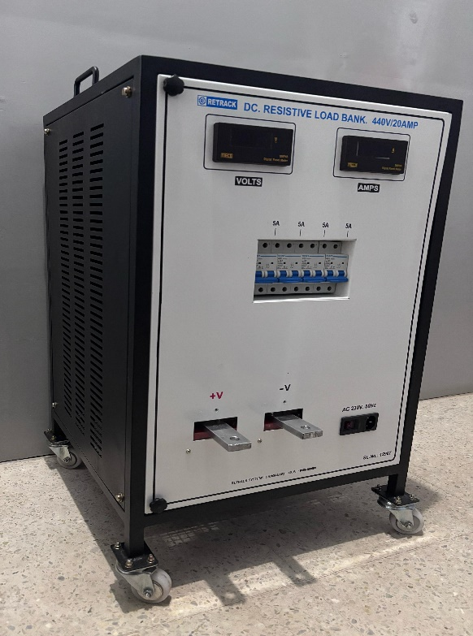  Note:  *Above shown image is for representation purpose only.  RETRACK SYSTEMS  #1038,’Hombelaku’,  11th main, Hampinagar,  Vijayanagar 2nd Stage,  Bangalore – 560 040.  Mob:98447 59090 / 98863 59090  Web-www.retracksystems.com  Mail-sales@retracksystems.com/  retracksystems@gmail.com/  retrack_systems@yahoo.com  Range of our other products:
  TECHNICAL SPECIFICATION
  Voltage: | 440V DC
  Current: | 20A DC
  No of Steps: | 4 Steps  (5Ax4)
  Selection Type: | Suitable DC MCBs
  Indications
  Separate indicators for Voltmeter and Current Meters
  FEATURES
  Type of cooling: | Forced Air, using FAN
  Enclosure type: | The Load Bank will be Constructed with rugged M.S Sheets/Mess
  Painting: | Powder coating,(Black)
  Auxiliary Supply: | 230V AC With suitable 3pin socket on door for connecting Aux, AC Supply for cooling fans and meters
  Connection Terminals: | Suitable Bus bar
  Mobility: | Freely movable through suitable wheels
  Approx. Dimension:
  450 X 450 X 700 mm (Width x Depth x Height)
  RUGGED AND AESTHETIC MECHANICAL AND ELECTRICAL DESIGN
  SALIENT FEATURES:
  NON-CORROSIVE PROPERTY
  STABLE & RELIABLE FUNCTIONING
  HIGH LOAD STORAGE CAPACITY
  RELIABLE & SAFE
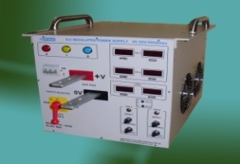 | 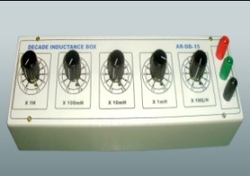 | 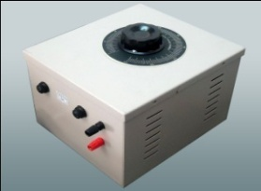 | 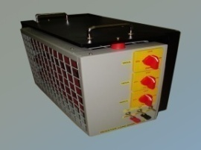 | 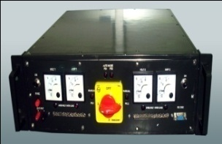
500A Regulated Power supply Decade RLC Boxes Auto Transformers R/L/C Load Bank Mil Grade Power Supplies \

CUSTOM MADE LOAD BANKS & POWER SUPPLIES ARE ALSO AVAILABLE

